PRESS RELEASE

**06/26/2019**

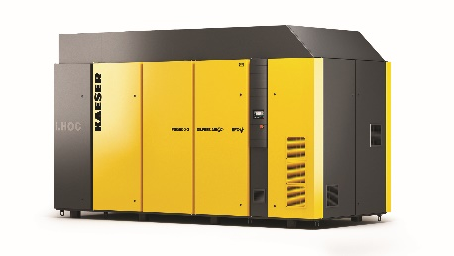*New FSG i.HOC compressors feature IE4 motor.*

***[Download a high resolution image here](https://us.kaeser.com/about-us/press/press-downloads/?download=360&utm_source=PR&utm_medium=PR)***[.](https://us.kaeser.com/about-us/press/press-downloads/?download=360&utm_source=PR&utm_medium=PR)

[Press Information Center](https://us.kaeser.com/about-us/press/default.aspx?utm_source=PR&utm_medium=PR)

[Contact us for contributions](mailto:pr.us@kaeser.com)

**FOR IMMEDIATE RELEASE**

**NEW OIL-FREE MODELS NOW AVAILABLE**

**Integrated, energy-saving desiccant dryers provide pressure dew points down to -22°F. New IE4 class drive motor for better efficiency.**

Kaeser’s new redesigned FSG series oil-free rotary screw compressors are now available with i.HOC® (integrated heat of compression) dryers and IE4 class drive motors. Available in both fixed speed and variable frequency drive from 250-450 hp, these reliable units feature a number of customizable options for exceptional energy efficiency and air quality.

Kaeser’s i.HOC dryers use the heat generated by compression to regenerate desiccant, eliminating the need for any additional energy in the drying process—even when air demand varies or in challenging environments. Full flow regeneration, along with an additional patented process, reliably provides pressure dewpoints to -22°F. The i.HOC oil-free compressors also feature a built-in heat recovery option and are designed to be space efficient without sacrificing serviceability.

FSG units come standard with Sigma Control 2™. This intelligent controller manages the entire drying process, while automatically adjusting to changes in air demand, maintaining consistent pressure dew points. Additionally, it offers unsurpassed compressor control and monitoring with enhanced communications capabilities for seamless integration into plant control/monitoring systems and the Internet of Things (IoT).

For more information, visit [**us.kaeser.com/oilfree**](https://us.kaeser.com/products-and-solutions/rotary-screw-compressors/oil-free-rotary-screw-compressors/?utm_source=PR&utm_medium=PR)**.** For more information or to be connected with your local authorized Kaeser representative, please call (877) 417-3527

|  |
| --- |
| **About Kaeser Compressors, Inc.:** Kaeser Compressors is a leader in reliable, energy efficient compressed air equipment and system design. We offer a complete line of superior quality industrial air compressors as well as dryers, filters, SmartPipe™, master controls, and other system accessories. Kaeser also offers blowers, vacuum pumps, and portable gasoline and diesel screw compressors. Our national service network provides installation, rentals, maintenance, repair, and system audits. Kaeser is an ENERGY STAR Partner.  **###** |

[f_logo.jpg](http://www.facebook.com/kaeserusa)[twitter-bird-white-on-blue.jpg](http://www.twitter.com/kaeserusa) [linkedin.jpg](http://www.linkedin.com/company/kaeser-compressors) [wordpress-logo-32-blue.png](http://www.kaesertalksshop.com) [YouTube.jpg](http://www.youtube.com/kaeserusa) [Instagram](https://www.instagram.com/kaeserusa/)