1/15/2026
FOR IMMEDIATE RELEASE

KAESER COMPRESSORS ANNOUNCES NEW FACTORY-DIRECT BRANCHES IN SOUTH FLORIDA
Kaeser Compressors announces new factory-direct branches in South Florida, ensuring expert sales and service from Key West to Port St. Lucie.
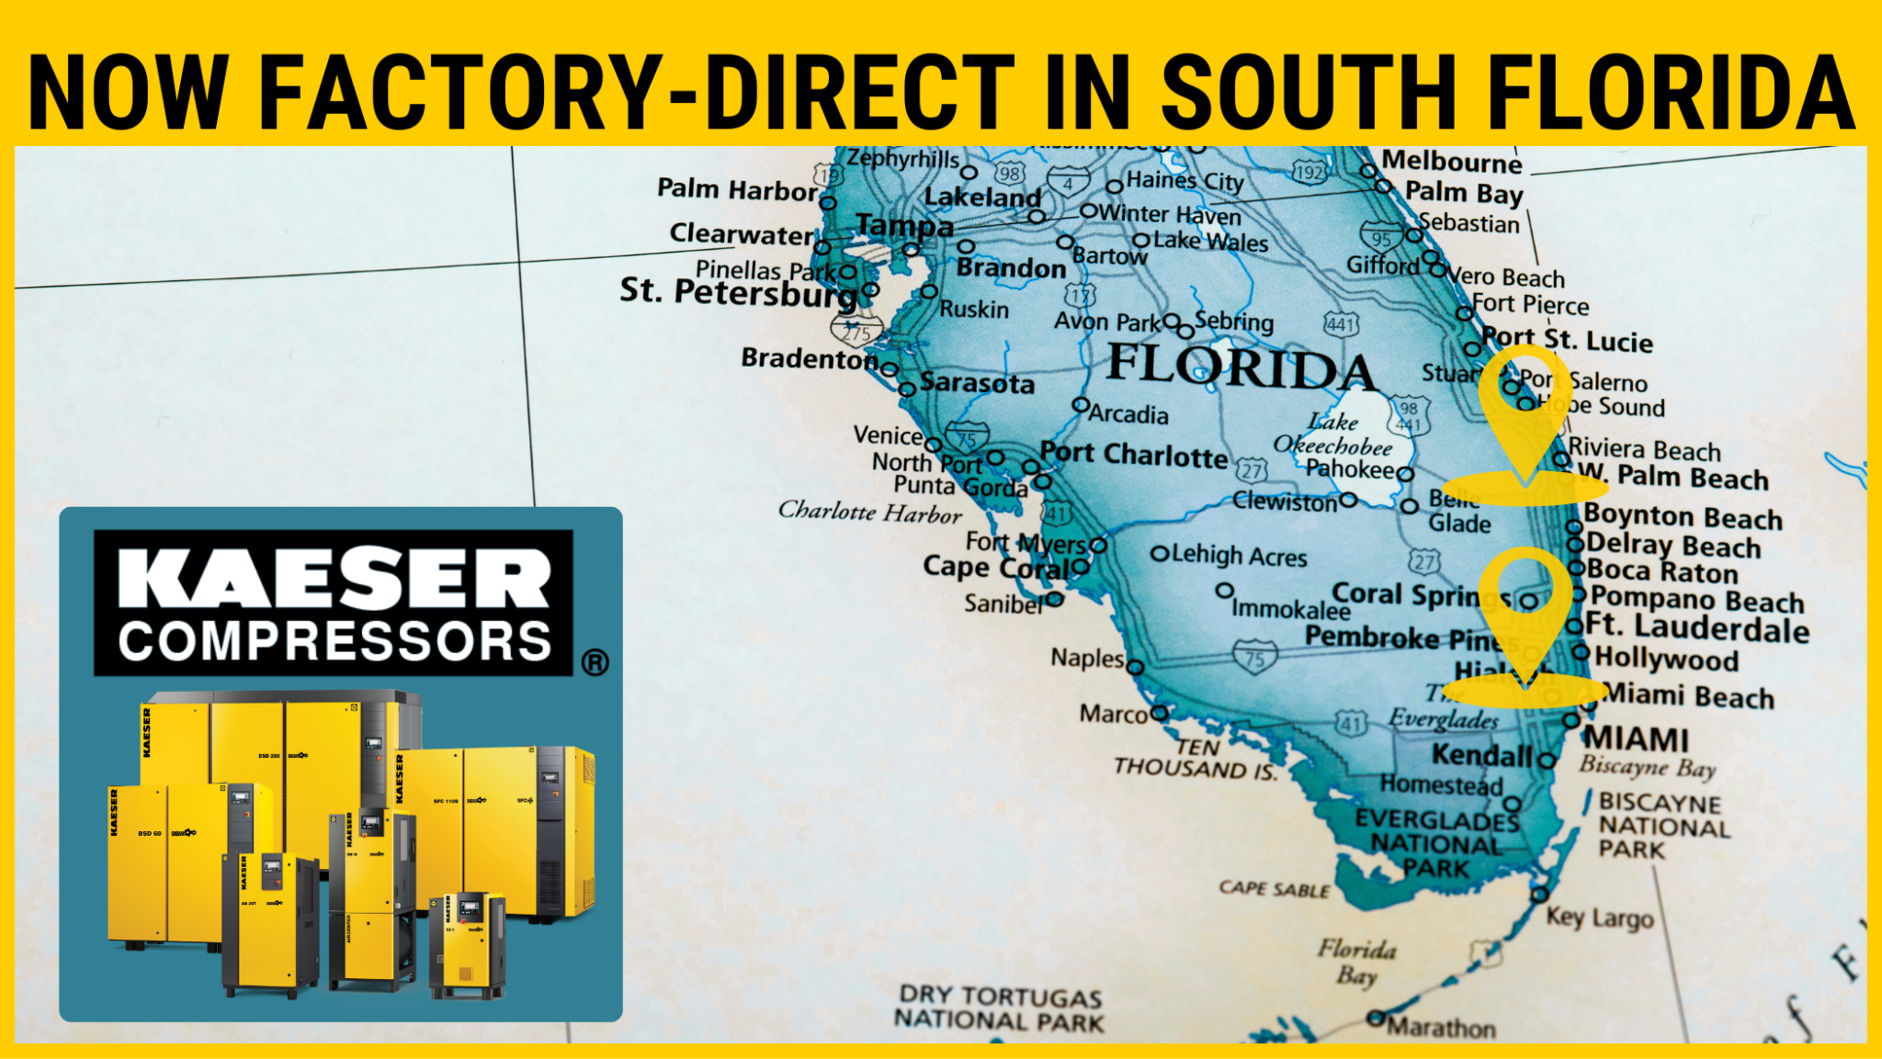
KAESER is now factory-direct in South Florida with sales and service support.

Download a high-resolution image here.
Kaeser Compressors, Inc. is excited to announce the opening of factory-direct branches to serve customers throughout South Florida. A combination of brick and mortar facilities and "mobile warehouse" service vehicles will provide direct manufacturer support—including KFaCT certified service, parts, equipment sales, and expert system engineering—to customers from Key West to Port St. Lucie.
“We are committed to providing our South Florida customers with the seamless support they deserve.” said Matt McCorkle, Director of Branch Operations. “We are on the ground and prepared to execute, ensuring our customers' systems achieve peak reliability and maximum energy efficiency without delay.”
Kaeser’s local team of certified experts is now available to assist with immediate needs, from routine maintenance and troubleshooting to complete system design and installation. The new branches offer a direct line to the manufacturer, ensuring faster response times and technical expertise for industrial, commercial, and institutional users.
For more information, visit us.kaeser.com/miami, email miami@kaeser.com, or call (800) 394-6095 to schedule a consultation or service visit.

