03/20/2025
FOR IMMEDIATE RELEASE

Mobilair M480: Unrivalled performance for demanding applications
The M480 is the most powerful oil-injected portable screw compressor in the MOBILAIR series, designed specifically for the North American market. With an impressive free air delivery of up to 1700 cfm, it sets new benchmarks in efficiency and versatility.
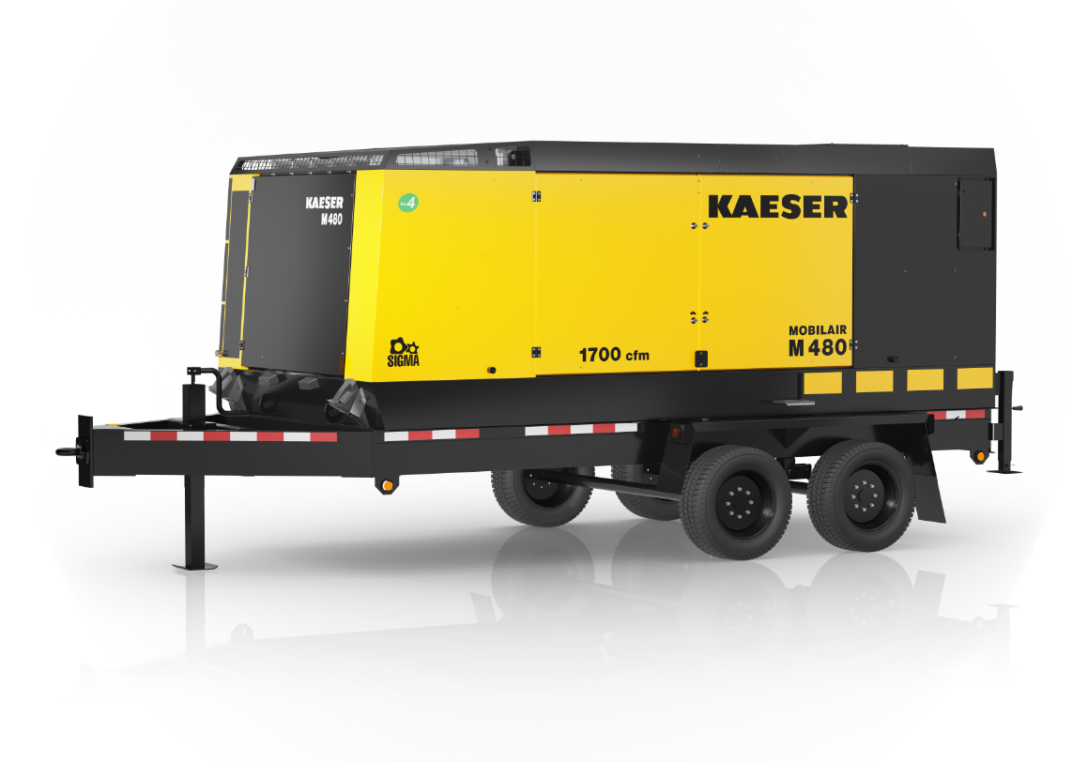
Combining power, efficiency, and ease of use, the M480 is the ideal choice for demanding construction and industrial applications across the USA and Canada.
Download a high-resolution image here.
At its core lies a high-performance 12-liter Cummins engine delivering 460 hp, fully compliant with stringent Tier 4 emissions standards, ensuring environmentally friendly yet exceptionally powerful operation.
Offering two continuously adjustable pressure ranges (87-125 psig and 87-200 psig), the M480 provides maximum flexibility. Its innovative pV control system automatically increases free air delivery when a lower operating pressure is selected, optimizing energy efficiency, and ensuring air supply is precisely matched to demand.
Versatile and robust, the M480 is ideal for a wide range of applications, from mining and tunnel construction to temporary replacement of industrial compressor stations. It can also be optionally equipped with air treatment systems to deliver cool, condensate-free, or technically oil-free compressed air.
Despite its exceptional power, the M480 is easy to operate, with a single switch to start the machine and an intuitive touch display for pressure adjustments in precise 1 psig increments.
The system is available in three configurations: a skid-mounted version, a stationary mount, and a DOT approved road-ready version featuring a heavy-duty chassis with an electric brake. No matter the configuration, a crane lifting eye, forklift pockets, and lashing points ensure safe and secure transportation.
Combining power, efficiency, and ease of use, the M480 is ready for large demanding applications.
For more information, visit us.kaeser.com/mobilair. To be connected with your local authorized Kaeser representative, please call (877) 417-3527.

