04/08/2025
FOR IMMEDIATE RELEASE

Kaeser Compressors Leads in Sustainability with New Solar Power Systems

Kaeser Compressors, Inc., is taking a significant step toward sustainability by installing two new solar systems at their Fredericksburg, Virginia facilities.
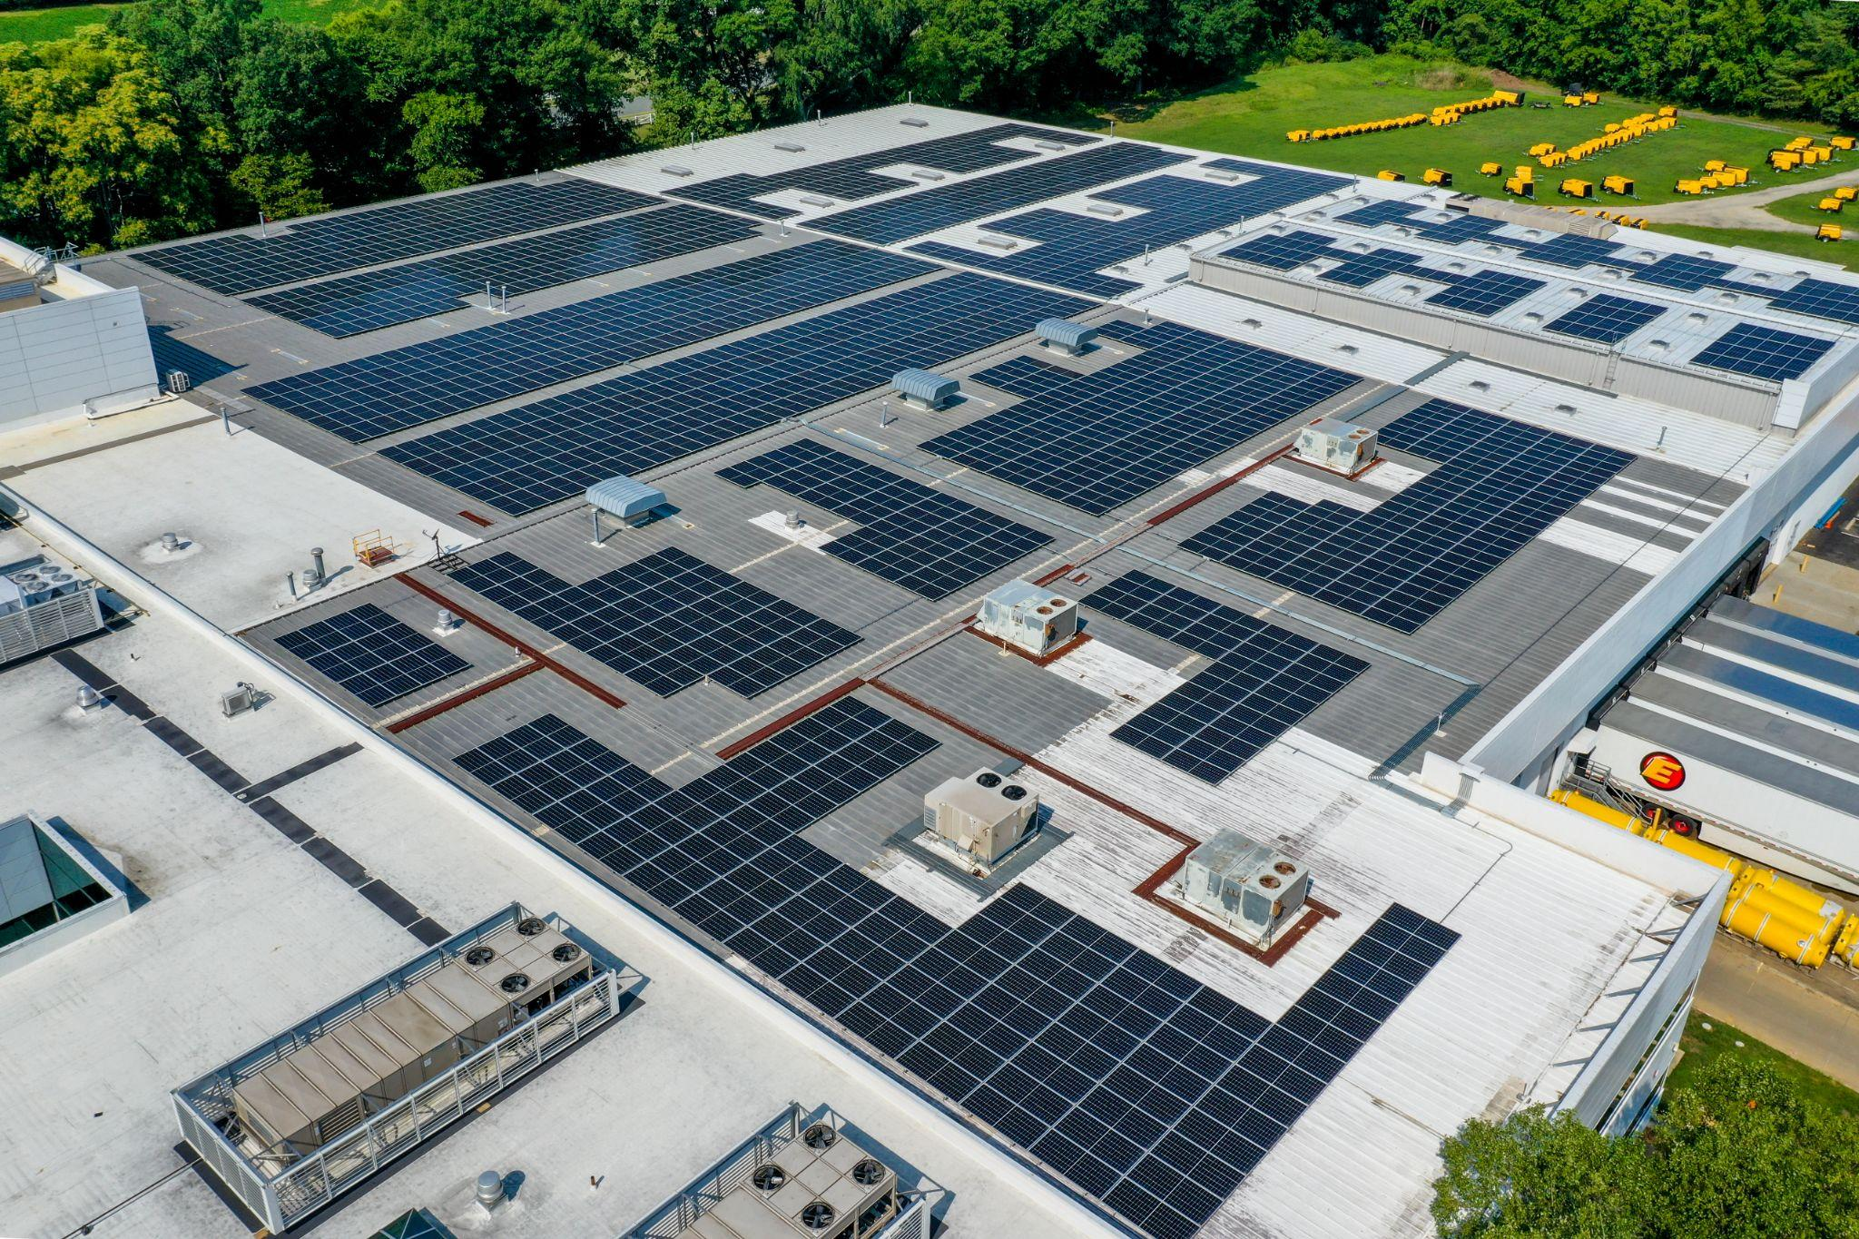
The solar systems at Kaeser Compressors' US headquarters in Fredericksburg, Virginia, are set to generate over 1.2 million kWh of clean energy annually, significantly reducing the facility's carbon footprint.

Download a high-resolution image here.
Kaeser Compressors, Inc. has completed the installation of two advanced solar power systems at their US headquarters. These systems are set to significantly reduce the company’s carbon footprint while generating clean, renewable energy to power their facilities.
The larger of the two solar systems will be connected directly to the power supply (transformer) of Kaeser’s original building, with an expected energy offset of 95%. The smaller system will be linked to the new power supply (transformer) for the recent office expansion. Due to the lack of historical energy use data for the new office space, the exact energy offset is yet to be determined. However, both systems are projected to generate a combined total of 1,208,486 kWh of electricity in their first year of operation, which equates to a reduction of approximately 856 metric tons of CO2 emissions.
“These solar installations mark a critical milestone in our commitment to sustainability,” said Frank Mueller, President of Kaeser Compressors. “We’re proud to harness solar power to drive our operations, demonstrating our dedication to reducing environmental impact and supporting renewable energy initiatives.”
The energy generated by these solar systems will not only power Kaeser’s facilities but also contribute to the wider grid. Dominion Energy provides credits for any excess energy production, which helps balance lower energy output during the winter months.
In addition, the solar power will support electric vehicle charging stations at the Fredericksburg facility. This aligns with Kaeser’s broader commitment to promoting clean energy and reducing reliance on fossil fuels.
The environmental benefits of these solar systems are substantial. The estimated carbon reduction is equivalent to taking 185 gasoline-powered cars off the road for one year or avoiding the consumption of 1,983 barrels of oil.
For more information about Kaeser Compressors, Inc. and our commitment to sustainability, please visit us.kaeser.com.

